UNIT_V (Emerging Trends in Engineering)
Robotics: Introduction and significance in automation, Classification (articulated, cartesian, cylindrical robots, etc.); Robot specifications (DOF, payload capacity, reach, repeatability), Introduction to SCARA robots.
3D Printing: Introduction and types of 3D printing technologies, materials used (plastics, metals, composites), 3D printing process workflow, applications and limitations.

Introduction to Robotics:

Robotics as a field finds its early inspiration in works of science fiction. The word robot itself comes from the English translation of a Czech play written around 1920. However, it was nearly four decades later that industrial robotics emerged as a real technological discipline. In the present day, robots are sophisticated mechanical manipulators, largely automated and directed through computer control. In this chapter, we will look at how robots were first imagined in literature and how the technology gradually evolved into what it is today. We will also define the term robotics and clarify its role within the broader scope of industrial automation.

Robot:
A robot is a reprogrammable, multifunctional manipulator designed to move materials, parts, tools, or specialized devices through variable programmed motions for the performance of a variety of tasks.”
In simple words A robot is a programmable machine (often with arms and joints) that can perform different tasks like handling, welding, painting, or assembly, depending on the instructions given.
Robotics:
Robotics is an applied engineering science that has been referred to as a combination of machine tool technology and computer science. It includes machine design, production theory, micro electronics, computer programming & artificial intelligence.
OR
"Robotics" is defined as the science of designing and building Robots which are suitable for real life application in automated manufacturing and other non-manufacturing environments.
Industrial robot:
The official definition of an industrial robot is provided by the robotics industries association (RIA). “Industrial robot is defined as an automatic, freely programmed, servocontrolled, multi-purpose manipulator to handle various operations of an industry with variable programmed motions”.
Automation:
Automation is the technology by which a process or procedure is accomplished without human assistance. It is implemented using a variety of means such as mechanical, electrical, hydraulic, pneumatic, electronic devices, and computers, usually in combination.
In simple words Automation means using technology to perform tasks automatically with little or no human involvement. Example: Automatic washing machine, CNC machines, assembly line in automobile industries.
Ex: - Robotics, CAD/CAM, FMS, CIMS
Key Difference:
Automation = Broad technology for automatic operation of processes.
Robotics = A branch of automation dealing specifically with programmable mechanical manipulators (robots).
Importance of Automation:
- Increases Productivity
Automation allows machines to operate continuously (24/7) without fatigue, leading to higher output.
- Improves Product Quality
Automated systems maintain precision and consistency, reducing human error and variability.
- Reduces Manufacturing Cost
Although initial investment is high, automation lowers long-term costs by reducing labor expenses and improving efficiency.
- Enhances Safety
Dangerous, repetitive, or hazardous tasks can be performed by machines instead of humans.
- Efficient Use of Materials
Automation minimizes waste and optimizes raw material usage through precise control.
- Increases Flexibility (in modern automation)
Programmable and flexible automation can handle different products and quick changeovers.
- Provides Better Working Conditions
Reduces human involvement in monotonous, dirty, or risky jobs.
- Enables Computer-Integrated Manufacturing (CIM)
Automation integrates design, production, and business functions through computer systems.
- Supports Mass Production
Makes large-scale manufacturing possible with consistent quality and speed.
- Strategic Advantage
Industries that adopt automation gain competitiveness in global markets due to efficiency and cost-effectiveness.
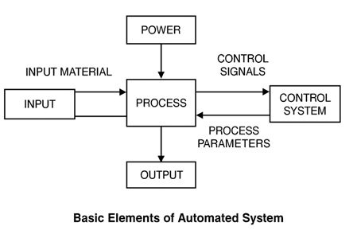
Types of Automation
Automation in manufacturing is generally divided into three types:
- Fixed Automation
- Programmable Automation
- Flexible Automation
1) Fixed Automation
The sequence of operations is fixed by the equipment configuration.
Suitable for high-volume production of one product.
Design changes are difficult and costly.
Features:
High production rate.
Low flexibility, no new product can be added.
Examples: Automobile assembly lines.
2) Programmable Automation
The sequence of operations can be changed using control programs.
Suitable for batch production (low or medium volume).
For each batch, a new program is loaded into the equipment.
Features:
High investment in general-purpose equipment.
Slower than fixed automation.
Flexible and allows product variation.
Examples: NC machines, industrial robots.
3) Flexible Automation
An advanced form of programmable automation.
Designed to reduce time lost in changeover between different products.
Produces different products continuously without reloading.
Features:
High investment cost.
Medium production rates.
Handles product design variations.
Examples: Flexible Manufacturing Systems (FMS).
Advantages of Automation
Higher production rates.
Reduced lead time.
Lower labour cost and fewer errors.
Improved product quality.
Disadvantages of Automation
High initial investment.
Expensive maintenance.
Requires skilled labour.
Increased cost for research and programming.

Robot anatomy and related attributes:

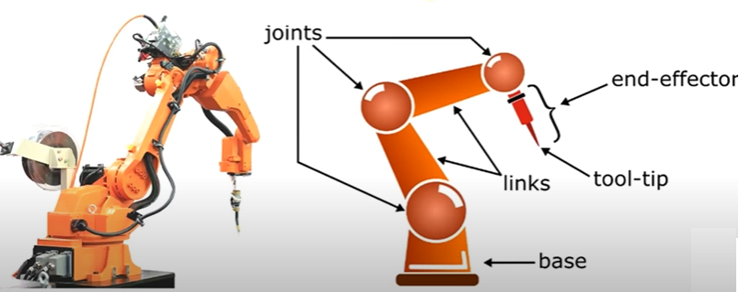

Classification of Robots by Configuration

Robots are classified based on their kinematic structure and movement capabilities. The principal configurations are:
- Cartesian Robots (Rectilinear or Gantry Robots)

A Cartesian Robot is a type of industrial robot whose arm has three prismatic joints, which move in straight lines along the X, Y, and Z axes of a Cartesian coordinate system. This makes them suitable for precise linear movements.

Axes of movement: X-axis, Y-axis, Z-axis (linear movements).

Configuration: Built on a rectangular coordinate system.

Actuators: Usually driven by linear actuators such as lead screws, belt drives, or linear motors.

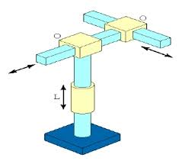

Diagram: Cartesian Robots

Flowchart of Working of Cartesian Robots:

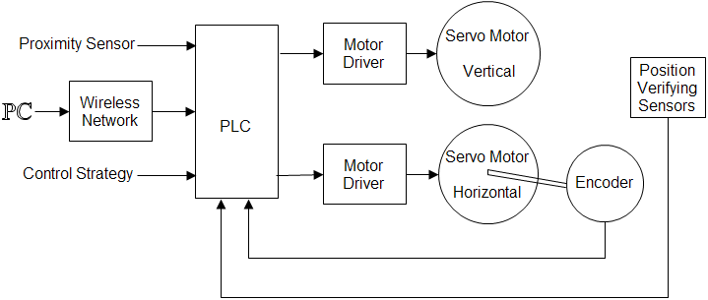
Working Flow of Cartesian Robot:
- Input Stage
Proximity Sensor: Detects the presence of an object or workpiece.
PC via Wireless Network: Provides task commands (e.g., pick, place, drill).
Control Strategy: Predefined program/logic instructions.
All these signals are fed into the PLC (Programmable Logic Controller).
- PLC (Central Control Unit)
The PLC processes inputs from sensors and the PC.
It generates control signals for the motor drivers to move the robot along required Cartesian axes.
It ensures synchronization between horizontal (X, Y) and vertical (Z) movements.
- Motor Drivers
Amplify PLC signals and supply required power to the servo motors.
One driver controls the Vertical Servo Motor (Z-axis).
Another driver controls the Horizontal Servo Motor (X/Y-axis).
- Servo Motors
Vertical Servo Motor → Controls up/down (Z-axis) movement.
Horizontal Servo Motor → Controls left/right (X-axis) and forward/backward (Y-axis) movement.
- Feedback System
Encoder: Attached to horizontal servo motor, measures displacement/rotation and sends position feedback to PLC.
Position Verifying Sensors: Ensure the end-effector reaches the exact programmed position.
This closed-loop control ensures high precision and repeatability.
- Execution
Based on feedback, the PLC continuously adjusts motor control.
The robot executes the task (pick & place, drilling, cutting, etc.) accurately.
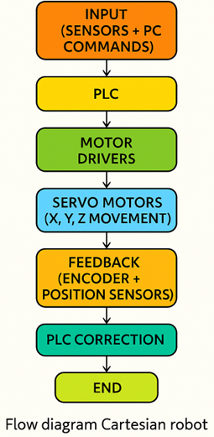
Simplified Flow Explanation
Input (Sensors + PC commands) → PLC → Motor Drivers → Servo Motors (X, Y, Z movement) → Feedback (Encoder + Position Sensors) → PLC correction → Accurate Task Execution
Advantages:
- High accuracy and repeatability.
- Simple design and control due to linear motion.
- Easy to program and maintain.
- Cost-effective compared to articulated robots.
- High rigidity and load-carrying capacity.
- Suitable for large workspaces (gantry configuration).
Disadvantages:
- Limited to rectangular workspaces.
- Requires large installation space.
- Not suitable for complex paths (like curved surfaces).
- Slower in operations required multi-axis rotation.
- Lower flexibility compared to articulated robots.
Applications:
- Pick and place operations.
- CNC machine tool operations.
- 3D printing (additive manufacturing).
- Automated storage and retrieval systems.
- Welding, cutting, drilling, and assembly lines.
- Large-scale gantry systems for heavy material handling.
- Cylindrical Robots:
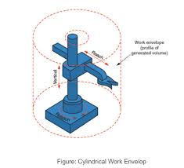
Cylindrical robots are a type of industrial robot with a cylindrical coordinate system. Their work envelope resembles a cylinder, and they combine rotary motion and linear motion. These robots are widely used in assembly, handling, and machine tool operations.
Axes of Movement
Cylindrical robots generally have 3 main axes of motion:
- Rotary axis (θ): Rotation around the base (about the vertical axis).
- Linear vertical axis (Z): Up and down movement.
- Linear radial axis (R): Inward and outward extension of the arm.
Configuration
Base: Provides rotary motion.
Column: Vertical structure enabling up–down motion.
Arm/Slide: Provides radial in–out movement.
End-effector (gripper/tool): Performs tasks such as handling, welding, or assembly.
The configuration makes them compact and suitable for tasks requiring vertical and radial operations.
Actuators
Actuators are devices that generate movement in the robot. Cylindrical robots use:
Electric Motors: For rotary motion (servo or stepper motors).
Hydraulic Actuators: For high force applications (lifting heavy loads).
Pneumatic Actuators: For fast, light operations.
Each actuator controls one axis of movement.
Flow Chart of Working
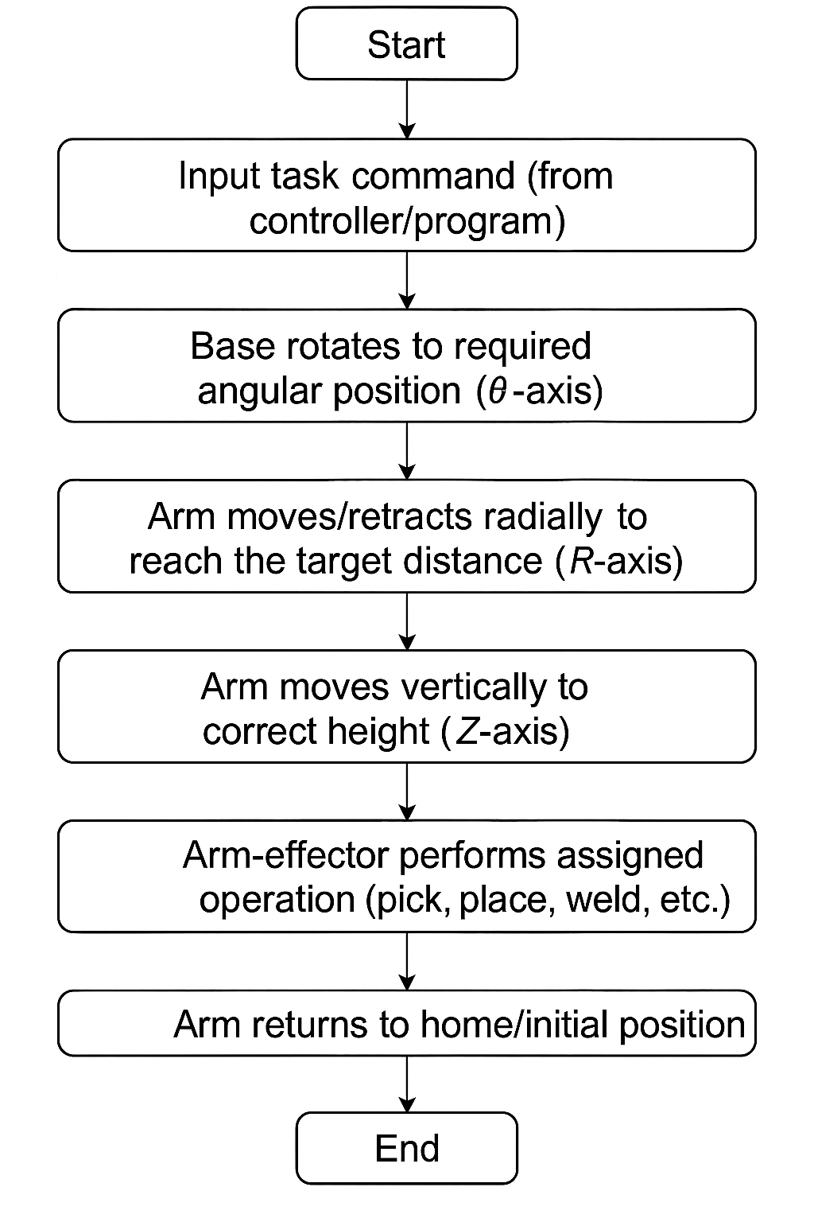
Here’s the working flow of a cylindrical robot:
Step 1: Start →
Step 2: Input task command (from controller/program) →
Step 3: Base rotates to required angular position (θ-axis) →
Step 4: Arm extends/retracts radially to reach the target distance (R-axis) →
Step 5: Arm moves vertically to correct height (Z-axis) →
Step 6: End-effector performs assigned operation (pick, place, weld, etc.) →
Step 7: Arm returns to home/initial position →
Step 8: End.
Advantages
- Simple design and control.
- Compact and efficient for vertical and radial tasks.
- Suitable for machine loading/unloading operations.
- Easier programming compared to articulated robots.
- Good reach within a cylindrical workspace.
Disadvantages
- Limited flexibility compared to articulated robots.
- Cannot cover irregular workspaces.
- Less suitable for tasks requiring complex 3D motion.
- Payload capacity lower than some other robot types.
Applications
- Assembly line operations.
- Machine tool handling (loading/unloading).
- Spot welding and die casting.
- Material handling and packaging.
- Pick-and-place tasks.
- Handling radioactive or hazardous materials.
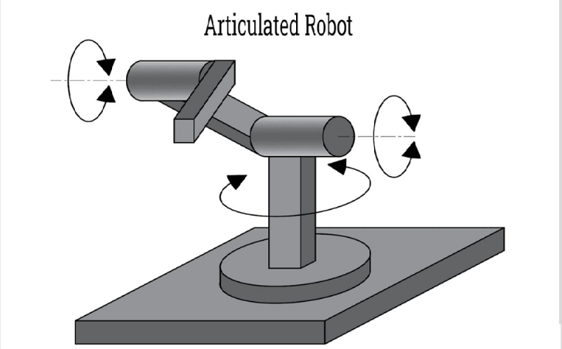
- Articulated Robots
An articulated robot is a robot with rotary joints, resembling the motion of a human arm. Depending on the number of joints, it can have 4 to 10 degrees of freedom (DOF), with 6 DOF being the most common. Its flexibility makes it the most widely used robot type in manufacturing, automation, and research.
Axes of Movement
Articulated robots operate through rotary joints that provide different degrees of motion:
- Base Rotation (θ-axis): Rotates the entire robot around the vertical axis.
- Shoulder Joint: Moves the arm forward and backward.
- Elbow Joint: Extends and retracts the arm, increasing reach.
- Wrist Pitch: Up and down movement of the wrist.
- Wrist Yaw: Side-to-side movement of the wrist.
- Wrist Roll: Rotational movement of the wrist for tool alignment.
With these joints, articulated robots achieve complex 3D movement similar to the human arm.
Configuration
Base: Provides support and allows rotation of the robot.
Shoulder: First large joint that lifts/lowers the arm.
Elbow: Adjusts reach and extends the workspace.
Wrist: Composed of multiple smaller joints for tool orientation.
End-effector: Tool or gripper attached for performing tasks (welding torch, paint spray, suction, etc.).
Workspace: A spherical or irregular 3D shape, allowing flexible movement in multiple directions.
Actuators
Actuators are the driving elements of motion in articulated robots:
Electric Actuators (servo/stepper motors): Provide precise and controlled motion, common in modern robots.
Hydraulic Actuators: Used where high force and heavy payload handling are required (e.g., automotive industry).
Pneumatic Actuators: Suitable for lightweight, high-speed, repetitive operations.
Hybrid Systems: Combination of electric and hydraulic actuators for specific applications.
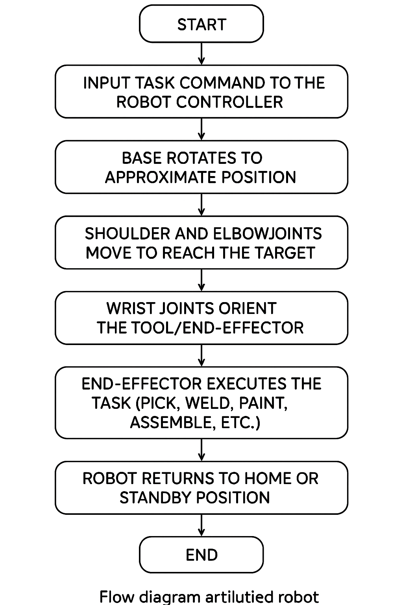
Flow Chart of Working
Step 1: Start →
Step 2: Input task command to the robot controller →
Step 3: Base rotates to approximate position →
Step 4: Shoulder and elbow joints move to reach the target →
Step 5: Wrist joints orient the tool/end-effector →
Step 6: End-effector executes the task (pick, weld, paint, assemble, etc.) →
Step 7: Robot returns to home or standby position →
Step 8: End
(This flow chart represents the sequence of movements and task execution in an articulated robot.)
Advantages, Disadvantages, and Applications
Advantages
- High flexibility and versatility.
- Can perform complex 3D operations.
- High speed and precision in repetitive tasks.
- Capable of handling different tools (multi-functional).
- Closely mimics human arm movement.
Disadvantages
- Higher installation and maintenance costs.
- Complex programming and calibration required.
- Requires skilled operators.
- Larger footprint compared to some simpler robots (e.g., SCARA, Cartesian).
Applications
- Welding: Spot welding and arc welding in the automobile industry.
- Material Handling: Loading/unloading, packaging, palletizing.
- Assembly: Electronics, automotive components, machinery.
- Painting & Coating: Applying paint to complex surfaces.
- Pick-and-Place Operations: Logistics, production lines.
- Medical Applications: Surgical robots, rehabilitation aids.
Comparative Layout
Feature | Articulated Robot | Cartesian Robot | Cylindrical Robot
Structure | Human-arm-like with joints | X-Y-Z linear axes | Rotary + linear movements
Workspace | Irregular, flexible | Rectangular (box-shaped) | Cylindrical volume
DOF | 4–6+ | 3 | 3
Applications | Welding, painting, assembly | CNC, 3D printing, pick & place | Spot welding, loading/unloading
Flexibility | Very high | Limited to straight-line | Moderate

Robot Specifications:
- Degrees of Freedom (DOF)
Definition: The number of independent movements a robot can perform. Each axis of motion adds one degree of freedom.
Typical Range: Industrial robots usually have 4 to 7 DOF.
For example:
A human arm has 7 DOF:
Shoulder (up/down)
Shoulder (forward/backward)
Shoulder (rotation)
Elbow (bend/straighten)
Wrist (up/down)
Wrist (side-to-side)
Wrist (rotation)
This makes it very flexible, almost like a robot manipulator.
Types of Movements in DOF
Robots achieve DOF through joints, and each joint can be:
Rotational (Revolute Joint) → rotates around an axis (like a shoulder or elbow).
Translational (Prismatic Joint) → moves in a straight line (like a sliding rail).
Each independent joint count as 1 DOF.
Example:
FANUC M-410iC/185 – 4-axis robot used for palletizing.
Universal Robots UR10e – 6-axis collaborative robot for flexible tasks.
- Payload Capacity in Robotics:
Payload capacity of a robot is the maximum weight it can safely lift, carry, or manipulate at its end effector (tooling point, like a gripper or welding gun). It is usually measured in kilograms (kg) or pounds (lb).
The payload includes:
- The object being handled (workpiece, box, part, etc.)
- The end effector itself (gripper, suction cup, welding torch, etc.
- Any additional tooling or sensors mounted on the wrist.
For example:
If a robot has a 10 kg payload capacity and your gripper weighs 2 kg, then it can only lift a workpiece of 8 kg safely.
Why Payload Capacity Matters
Safety: Overloading can damage the robot joints, motors, or cause accidents.
Accuracy: A robot operating near or beyond its payload limit will lose precision.
Application Suitability: The right payload ensures the robot can do the job efficiently.
Durability: Running consistently over the rated payload reduces robot life.
Factors Affecting Payload
- Robot Design & Build: Heavy-duty robots (like palletizing robots) are stronger but less flexible; lightweight collaborative robots (cobots) have lower payload.
- Reach/Arm Extension: The farther the arm stretches, the less payload it can handle (due to torque and leverage).
- Speed of Operation: At higher speeds, effective payload may be lower to avoid instability.
- Tooling Weight: Heavier grippers/tools reduce how much product the robot can handle.
Typical Payload Ranges
Collaborative Robots (Cobots): 3–20 kg (safe to work alongside humans, limited strength).
Example: UR3e → 3 kg, UR10e → 12.5 kg.
Articulated Industrial Robots: 10–500 kg (used in assembly, welding, machine tending).
Example: ABB IRB 6700 → 150 kg.
Palletizing Robots: 100–700 kg (lifting heavy boxes or bags).
Example: FANUC M-410iC/500 → 500 kg.
Special Heavy-Duty Robots: >1,000 kg (automotive, aerospace, or shipbuilding).
Example: KUKA Titan → 1,300 kg.
Examples
- Universal Robots UR10e (Collaborative Robot):
Payload: 12.5 kg
Suitable for medium-weight tasks like assembly, packaging, and light machine tending.
- FANUC M-410iC/185 (Palletizing Robot):
Payload: 185 kg
Designed for high-speed stacking of heavy boxes/bags.
- KUKA KR 1000 Titan (Heavy-Duty Robot):
Payload: 1,300 kg
One of the world’s strongest industrial robots, used in shipbuilding, construction, aerospace.
- Reach:
Reach is the maximum distance a robot arm can extend from its base. It describes how far the robot can stretch to pick, place, weld, or manipulate objects. Reach is measured in millimetres (mm) or meters (m).
Types of Reach: Robots usually specify reach in two dimensions:
Horizontal Reach
The distance from the robot’s base centre to the furthest point it can reach forward. Important for tasks that spread out over a wide table, conveyor, or assembly line.
Vertical Reach
The height from the base to the highest point the robot arm can extend upward. Important for stacking, palletizing, or accessing tall equipment.
Example:
KUKA KR QUANTEC – Reach up to 3101 mm
Universal Robots UR30 – Reach up to 2600 mm
- Repeatability:
Repeatability is the ability of a robot to return to the exact same position or point in space multiple times under the same conditions. It measures how consistently the robot can hit the same target point during repetitive tasks.
Units
Repeatability is measured in millimetres (mm).
A smaller value indicates higher precision. For example:
A repeatability of ±0.02 mm is extremely precise (common in high-end industrial robots used for electronics or medical applications).
A repeatability of ±0.5 mm is less precise (common in general-purpose industrial robots like welding or palletizing).
Example:
FANUC M-20iA – Repeatability of ±0.08 mm
ABB IRB 4600 – Repeatability of ±0.05 mm
- Motion in Robotics
Definition
Motion refers to the movement of a robot’s joints and end-effector within its workspace. Robots achieve motion through actuators (motors, hydraulics, pneumatics) controlled by a robot controller. Motion determines how the robot moves: in straight lines, curves, arcs, or rotations.
Types of Robot Motion
- Linear Motion (Prismatic Joints)
End-effector moves in a straight line (X, Y, or Z direction).
Example: Cartesian robots (used in CNC machines, 3D printing).
- Rotary Motion (Revolute Joints)
Joints rotate around an axis, producing angular displacement.
Example: Articulated 6-axis robots (welding, assembly).
- Cylindrical / Spherical Motion
Combination of rotary + linear motion.
Example: SCARA robots (fast pick-and-place).
- Complex Motion (Multi-axis Combination)
Robots can perform 3D trajectories (arc welding, painting, surgery).
Motion type defines robot structure, applications, and flexibility.
Example:
Cartesian robot → precise straight-line motions (CNC, drilling).
Delta robot → ultra-fast curved motions (packaging, electronics).

- Speed in Robotics
Definition
Motion speed is the rate at which the robot’s joints or end-effector move. Determines how quickly tasks like welding, pick-and-place, or assembly can be performed.
Units
Rotary joints: Degrees per second (°/s)
Linear joints / End-effector: Meters per second (m/s) or Millimeters per second (mm/s)
Typical Speed Ranges
Articulated Robots (6-axis): 1–3 m/s TCP speed, joints up to 300–500 °/s
SCARA Robots: 3–6 m/s TCP speed, very high joint speeds
Delta Robots (high-speed pick-and-place): up to 10 m/s, >150 picks/min
Factors Affecting Speed
- Payload → heavier loads reduce speed.
- Robot Type → Delta/SCARA are faster than articulated.
- Control Algorithms → smooth path planning avoids jerks at high speed.
- Accuracy Requirements → high-speed motion may compromise precision.
Examples
Fanuc M-2iA (Delta robot): End-effector speed up to 10 m/s.
ABB IRB 1600: Wrist speed 520 °/s, TCP linear speed ~2.6 m/s.
- Range in Robotics
Definition
Motion range is the extent of movement possible in each robot joint. Determines the workspace volume (the 3D area where the robot can operate).
Units
Rotary joints: Degrees (°)
Linear joints: Millimetres (mm) or Meters (m)
Typical Joint Ranges (6-axis articulated robot example)
- Base rotation (J1): ±170° to ±360°
- Shoulder (J2): -90° to +150°
- Elbow (J3): -200° to +200°
- Wrist roll (J4): ±200°
- Wrist pitch (J5): ±120°
- Wrist yaw (J6): ±360° (continuous)
Examples
Universal Robots UR10e: Joint rotation ±360° continuous.
KUKA KR QUANTEC: Wrist roll up to ±350°.
SCARA robot: Large X-Y range, but limited Z-axis motion.

Comparison Table
Feature | Definition | Units | Typical Range | Example Applications
Motion | Type of movement (linear, rotary, combined) | – | Depends on robot type | CNC (linear), SCARA (planar), Articulated (complex 3D)
Speed | Rate of movement of joints/end-effector | °/s, m/s | 1–10 m/s, 100–500 °/s | Pick-and-place, welding, packaging
Range | Extent of movement possible per joint | ° or mm | ±90° to ±360° (rotary), 0.5–3 m (linear reach) | Large workspace tasks, painting, assembly
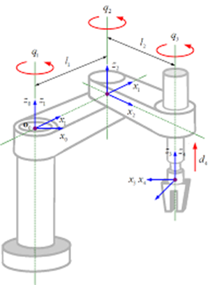
SCARA Robots (Selective Compliance Assembly Robot Arm):
A SCARA Robot (Selective Compliance Assembly Robot Arm) is a type of industrial robot designed primarily for assembly, packaging, and pick-and-place tasks. Introduced in the early 1980s in Japan, the SCARA robot became popular in electronics manufacturing, where high speed and precision are critical.
The term “Selective Compliance” means:
Compliant (flexible) in the X-Y plane → allows slight bending in horizontal direction, making it ideal for insertion and assembly.
Rigid in the Z-axis → ensures accurate vertical motion without wobbling.
This combination makes SCARA robots highly effective in repetitive, precise, and high-speed 2D operations.

Structure and Configuration
A SCARA robot typically has 4 Degrees of Freedom (DOF):
- Base Joint (θ1): Rotational joint at the base, rotates the first arm.
- Shoulder Joint (θ2): Rotational joint connecting the second arm.
- Vertical Motion (Z-axis): Linear prismatic joint for up and down movement.
- Wrist Joint (θ4): Rotational joint at the end-effector for tool orientation.
Components
Base: Fixed to the ground or table, provides stability.
Arm 1 & Arm 2: Two rotary links for horizontal movement.
Vertical Slide: Provides up-down motion for handling objects.
End-Effector: Tool such as a gripper, suction cup, or soldering tool.

Workspace
The workspace of a SCARA robot is generally cylindrical or annular (donut-shaped).
The two rotary arms create a wide planar reach (X-Y plane), while the vertical slide adds Z-axis motion.
This makes it suitable for tasks requiring horizontal reach with vertical placement.

Motion Characteristics
DOF: 4 (2 rotary + 1 linear + 1 rotary wrist).
Speed: Very high, up to 200 picks/minute (end-effector speeds 3–10 m/s).
Accuracy & Repeatability: ±0.01 mm to ±0.02 mm.
Payload: Typically, 2–20 kg.
Reach: 200–1000 mm (depending on model).

Advantages
- High Speed: Faster than articulated robots in 2D operations.
- High Precision: Excellent repeatability for assembly and electronics.
- Compact Design: Takes less space compared to 6-axis robots.
- Ease of Programming: Simple kinematics compared to articulated robots.
- Cost-Effective: Cheaper for specific tasks than complex robots.

limitations
- Limited Flexibility: Only 4 DOF; cannot handle complex 3D tasks.
- Restricted Payload: Not suitable for heavy loads.
- Limited Applications: Mostly used for light assembly, packaging, and electronics.

Applications
- Electronics Industry: PCB assembly, component insertion, soldering.
- Automotive Industry: Small part assembly, gear and bearing insertion.
- Food & Pharma: Packaging, labeling, bottle handling.
- General Manufacturing: Pick-and-place, dispensing, screw driving.

Industrial Examples
Yamaha YK-XE Series: High-speed SCARA for electronics assembly.
Epson LS6-B: Used in packaging and general automation.
ABB IRB 910SC: Compact SCARA for laboratory and light manufacturing.

Comparison with Other Robots
Feature | SCARA Robot | Articulated Robot (6-axis) | Cartesian Robot
DOF | 4 | 6 | 3 (linear)
Speed | Very high | Moderate | Low to moderate
Flexibility | Limited (2D tasks) | Very high (3D tasks) | Low
Workspace | Cylindrical | Spherical | Cuboidal
Applications | Assembly, packaging | Welding, painting, machining | CNC, 3D printing

